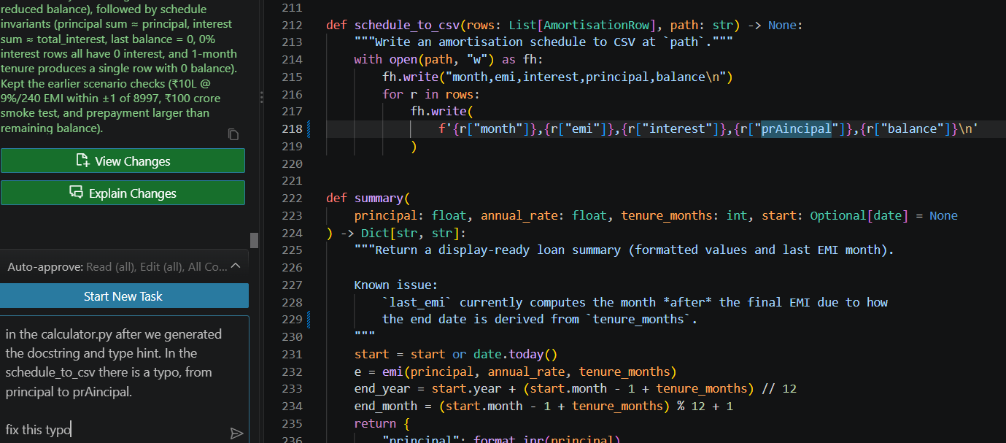
ScreenShot 1
After we generated the docstring and type hint, I realised that aXet has accidently changed the function way of working. aXet had a typo that cause principal to be changed to prAincipal. schedule_to_csv would have crashed on the first row, every time it’s called. Hence, I prompted aXet to fix that typo. Although it’s a small typo that I can fix, I asked aXet to fix it as theres a need for a prompt log record doc.

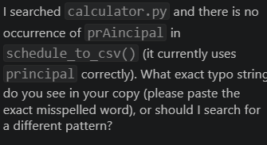
ScreenShot 2
aXet did not managed to find the typo in the calculator.py, which lead me to send another prompt containing a screenshot of the exact location.
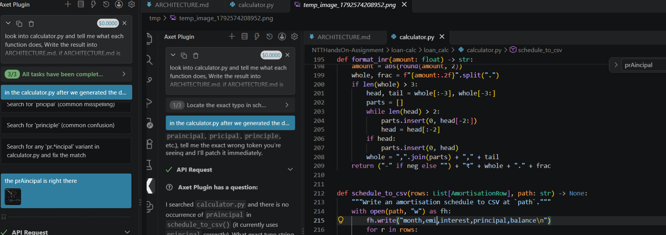
ScreenShot 3
Only then did aXet fix the typo.

